**URK22AI1048**

**Subject: 20CS2036L – Web Technology Lab HARIHARAN K**

**Lab Exercise: 5. JAVASCRIPT – DOM ELEMENTS AND EVENTS (Duration: 1.30**

**hours)**

**Instructions: Odd no’s (Q1, Q3, Q5), Even no’s (Q2, Q4, Q5) Note: Apply your creativity to design the templates**

**Aim:**

To create a web page which demonstrates dynamic actions for user interactions using JavaScript document object model methods and events.

**Description:**

**Include script in HTML page:**

In HTML, JavaScript code is inserted between <script> and </script> tags. Scripts can be placed in the

<body>, or in the <head> section of an HTML page, or in both. Internal script:

*<script>*

*document.write("Hello");*

*</script>*

External script:

*<script src="myscripts.js"></script>*

**Document Object Model:**

A Document object represents the HTML document that is displayed in that window. The Document object has various properties that refer to other objects which allow access to and modification of document content. The way a document content is accessed and modified is called the Document Object Model, or DOM.

Finding HTML Element by Id

*var myElement = document.getElementById("intro");*

Finding HTML Elements by Tag Name

*var x = document.getElementsByTagName("p");*

Finding HTML Elements by Class Name

*var x = document.getElementsByClassName("intro");*

Finding HTML Elements by CSS Selectors

*var x = document.querySelectorAll("p.intro");*

**Functions in JavaScript:**

*function display()*

*{*

*document.getElementById("demo").innerHTML = "Karunya";*

*}*

**JavaScript Events:**

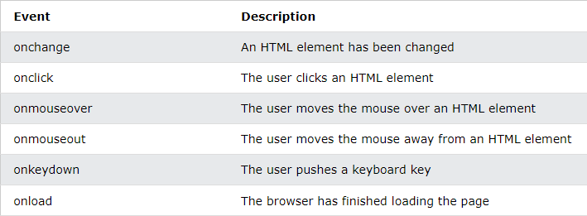JavaScript's interaction with HTML is handled through events that occur when the user or the browser manipulates a page.

**Handle events with button click:**

Call a function when a button is clicked:

*<input type="button" value="submit" onclick="display()">*

**Q1: BMI Calculator**

Create a web page with JavaScript program to calculate and display the BMI value for the given weight and heights (input from user). You should also describe the person’s body type based on their BMI score using the following criteria:

BMI = weight(kg)/[height(m)]2

* Underweight: < 18
* Normal: 18 – 25
* Overweight: 25 – 30
* Obese: > 30

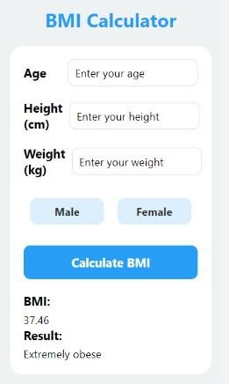

**Q2: Simple Calculator**

Create a web page with JavaScript program to perform basic mathematic operations such as addition, subtraction, multiplication, and division for the two given numbers (input from user).

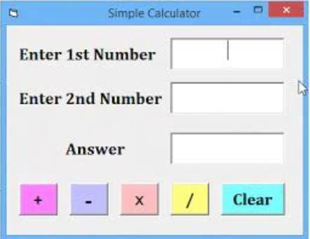

**Q3: Currency Convertor**

Create a web page with JavaScript program to develop currency convertor. Keep at least 4 currencies via drop down list box (<select> Element) as given in the sample output.

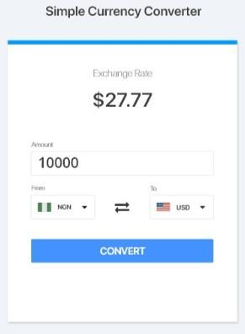

**Q4: EMI Loan Calculator**

Create a web application to develop the following Bank loan EMI calculator using client-side JavaScript. The formula to calculate EMI is P x R x (1+R)^N / [(1+R)^N-1] – where, “P” is the principal loan amount, “N” in tenure in months, and “R” is the prevailing interest rate.

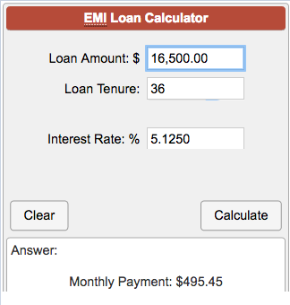

**Q5: Pizza Order Form**

Design a webpage using JavaScript program as per the following design and perform the Pizza order calculation.

Pizza size: 8-inch (2%), 10-inch (4%), 12-inch (6%), 14-inch (8%) Toppings: 10% cost for each selection

Tax is an additional 9% to the order. The user must also pay a tip from 10-20% of the total cost of the order after tax

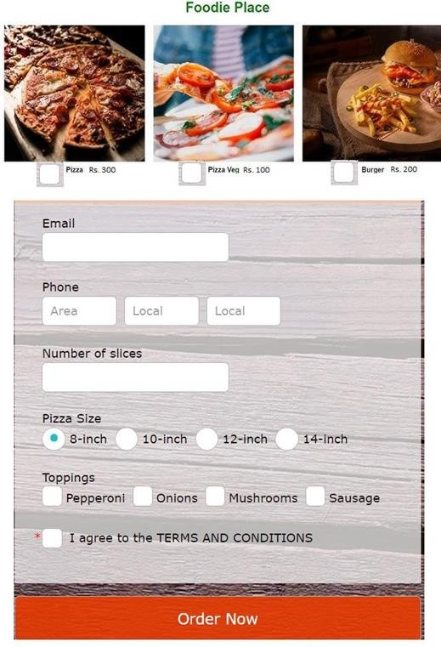

# CODE:

**calculator.html**

<!DOCTYPE html>

<html lang="en">

<head>

<meta charset="UTF-8">

<meta name="viewport" content="width=device-width, initial-scale=1.0">

<title>Simple Calculator</title>

<style>

body {

font-family: Arial, sans-serif; background-color: #f0f0f0;

}

h2 {

text-align: center;

}

form {

max-width: 400px; margin: 0 auto; background-color: #fff; padding: 20px;

border-radius: 8px;

box-shadow: 0 2px 5px rgba(0, 0, 0, 0.1);

}

input[type="number"], input[type="text"] { width: calc(50% - 10px);

padding: 10px; margin: 5px;

border: 1px solid #ccc; border-radius: 4px; box-sizing: border-box;

}

button {

width: calc(25% - 10px); padding: 10px;

margin: 5px; border: none; border-radius: 4px; cursor: pointer;

background-color: #4CAF50; color: white;

font-size: 18px;

transition: background-color 0.3s;

}

button:hover {

background-color: #45a049;

}

#result {

text-align: left; margin-top: 20px; font-size: 20px;

}

#answer {

width: calc(50% - 10px); padding: 10px;

margin: 5px;

border: 1px solid #ccc; border-radius: 4px; box-sizing: border-box;

}

</style>

</head>

<body>

<h2>Simple Calculator</h2>

<form id="calculatorForm">

<label for="num1">Enter 1 number</label>

<input type="number" id="num1" >

<br>

<label for="num2">Enter 2 number</label>

<input type="number" id="num2" >

<br>

<div id="result">Result: <input type="text" id="answer" readonly></div>

<button type="button" onclick="add()">+</button>

<button type="button" onclick="subtract()">-</button>

<button type="button" onclick="multiply()">x</button>

<button type="button" onclick="divide()">/</button>

<button type="button" onclick="clearFields()">Clear</button>

<script>

function add() {

var num1 = parseFloat(document.getElementById('num1').value); var num2 = parseFloat(document.getElementById('num2').value); var result = num1 + num2; document.getElementById('answer').value = result;

}

function subtract() {

var num1 = parseFloat(document.getElementById('num1').value); var num2 = parseFloat(document.getElementById('num2').value); var result = num1 - num2; document.getElementById('answer').value = result;

}

function multiply() {

var num1 = parseFloat(document.getElementById('num1').value); var num2 = parseFloat(document.getElementById('num2').value); var result = num1 * num2; document.getElementById('answer').value = result;

}

function divide() {

var num1 = parseFloat(document.getElementById('num1').value); var num2 = parseFloat(document.getElementById('num2').value); if (num2 === 0) {

alert("Division by zero is not allowed"); return;

}

var result = num1 / num2; document.getElementById('answer').value = result;

}

function clearFields() { document.getElementById('num1').value = ''; document.getElementById('num2').value = ''; document.getElementById('answer').value = '';

}

</script>

</form>

</body>

</html>

# EMICalculator.html

<!DOCTYPE html>

<html lang="en">

<head>

<meta charset="UTF-8">

<meta name="viewport" content="width=device-width, initial-scale=1.0">

<title>EMI Loan Calculator</title>

<style>

body {

font-family: Arial, sans-serif; background-color: #f0f0f0; margin: 0;

padding: 0;

}

.container {

max-width: 600px; margin: 50px auto; background-color: #fff; padding: 20px;

border-radius: 8px;

box-shadow: 0 2px 5px rgba(0, 0, 0, 0.1);

}

h2 {

text-align: center;

}

label {

display: block; margin-bottom: 5px;

}

input[type="number"], input[type="text"] {

width: 100%; padding: 10px; margin-bottom: 15px;

border: 1px solid #ccc; border-radius: 4px; box-sizing: border-box;

}

.button-container { display: flex;

justify-content: space-between; align-items: center;

margin-bottom: 15px;

}

button { width: 48%;

padding: 10px; border: none; border-radius: 4px; cursor: pointer;

background-color: #4CAF50; color: white;

font-size: 18px;

transition: background-color 0.3s;

}

button:hover {

background-color: #45a049;

}

#emiResult {

text-align: center; margin-top: 20px; font-size: 20px;

}

</style>

</head>

<body>

<div class="container">

<h2>EMI Loan Calculator</h2>

<label for="principal"> Loan Amount: $</label>

<input type="number" id="principal" placeholder="Enter loan amount">

<label for="interest">Interest Rate: %</label>

<input type="number" id="interest" placeholder="Enter annual interest rate">

<label for="tenure">Loan Tenure:</label>

<input type="number" id="tenure" placeholder="Enter loan tenure in months">

<div class="button-container">

<button type="button" onclick="calculateEMI()">Calculate EMI</button>

<button type="button" onclick="clearResult()">Clear</button>

</div>

<label for="emiOutput">Monthly Payment: $</label>

<input type="text" id="emiOutput" readonly>

</div>

<script>

function calculateEMI() {

var principal = parseFloat(document.getElementById("principal").value);

var interestRate = parseFloat(document.getElementById("interest").value) / 1200; // Monthly interest rate

var tenureMonths = parseFloat(document.getElementById("tenure").value);

var emi = principal * interestRate * Math.pow(1 + interestRate, tenureMonths) / (Math.pow(1 + interestRate, tenureMonths) - 1);

document.getElementById("emiOutput").value = emi.toFixed(2);

}

function clearResult() { document.getElementById("emiOutput").value = ""; document.getElementById("principal").value = ""; document.getElementById("interest").value = ""; document.getElementById("tenure").value = "";

}

</script>

</body>

</html>

# Pizza Order Form

<!DOCTYPE html>

<html lang="en">

<head>

<meta charset="UTF-8">

<meta name="viewport" content="width=device-width, initial-scale=1.0">

<title>Pizza Order Form</title>

<style>

body {

font-family: Arial, sans-serif; background-color: #f0f0f0; margin: 0;

padding: 0;

}

.container {

max-width: 600px; margin: 50px auto; background-color: #fff; padding: 20px;

border-radius: 8px;

box-shadow: 0 2px 5px rgba(0, 0, 0, 0.1);

}

h2 {

text-align: center;

}

label {

display: block; margin-bottom: 5px;

}

input[type="number"], input[type="email"], input[type="tee"],input[type="te2"],input[type="te3"] {

width: calc(33.3% - 10px); padding: 10px;

margin-bottom: 15px; border: 1px solid #ccc; border-radius: 4px; box-sizing: border-box;

}

.sizes input[type="number"] { width: calc(25% - 10px);

}

button {

width: 100%; padding: 10px; border: none; border-radius: 4px; cursor: pointer;

background-color: #4CAF50; color: white;

font-size: 18px;

transition: background-color 0.3s;

}

button:hover {

background-color: #45a049;

}

#totalCost {

text-align: center; margin-top: 20px; font-size: 20px;

}

.images-container { display: flex;

justify-content: space-between; align-items: center;

margin-bottom: 15px;

}

.images-container img { width: 30%;

}

.sizes, .toppings { display: flex; flex-wrap: wrap;

justify-content: space-between; margin: 25px;

}

.bk{

display:flex;

justify-content: first baseline; margin: 25px;

}

.sizes input[type="radio"], .toppings input[type="checkbox"] { margin-right: 10px;

.images-container input[type="checkbox"] { margin-right: 10px;

}

}

</style>

</head>

<body>

<div class="container">

<h2>Foodie Place</h2>

<div class="images-container">

<div>

<img src="p1.jpeg" alt="Pizza 1">

<label><input type="checkbox" name="pizza" value="pizza1"> Pizza Rs.300</label>

</div>

<div>

<img src="p2.jpeg" alt="Pizza 2">

<label><input type="checkbox" name="pizza" value="pizza2"> Pizza Veg Rs.

100</label>

</div>

<div>

<img src="p3.jpeg" alt="Pizza 3">

<label><input type="checkbox" name="pizza" value="pizza3"> Burger Rs.200</label>

</div>

</div>

<label for="email">Email:</label>

<input type="email" id="email" >

<label for="phone">Phone:</label>

<input type="tee" id="phone" placeholder="Area">

<input type="te2" id="phone" placeholder="Local">

<input type="te3" id="phone" placeholder="Local">

<label for="size">Number of Slices:</label>

<input type="number" id="size" min="0" >

<div class="sizes">

<label for="size">Pizza Size:</label>

<input type="radio" id="size8" name="size" value="8">

<label for="size8">8-inch</label>

<input type="radio" id="size10" name="size" value="10">

<label for="size10">10-inch</label>

<input type="radio" id="size12" name="size" value="12">

<label for="size12">12-inch</label>

<input type="radio" id="size14" name="size" value="14">

<label for="size14">14-inch</label>

</div>

<div class="toppings">

<label>Toppings :</label>

<input type="checkbox" id="toppingPepperoni" name="topping" value="Pepperoni">

<label for="toppingPepperoni">Pepperoni</label>

<input type="checkbox" id="toppingMushrooms" name="topping" value="Mushrooms">

<label for="toppingMushrooms">Mushrooms</label>

<input type="checkbox" id="toppingOnions" name="topping" value="Onions">

<label for="toppingOnions">Onions</label>

<input type="checkbox" id="toppingSausage" name="topping" value="Sausage">

<label for="toppingSausage">Sausage</label>

</div>

<div class="bk">

<input type="checkbox" id="terms" name="terms" value="con">

<label for="terms">I agree to the Terms and Conditions</label>

</div>

<button type="button" onclick="calculateTotal()">Order Now</button>

<p id="totalCost"></p>

</div>

<script>

function calculateTotal() {

const pizzaPrice = 300; const vegPizzaPrice = 100; const burgerPrice = 200;

const selectedPizzas = document.querySelectorAll('input[name="pizza"]:checked'); const selectedSize = document.querySelector('input[name="size"]:checked');

const selectedToppings = document.querySelectorAll('input[name="topping"]:checked'); const agreeTerms = document.getElementById('terms').checked;

if (selectedPizzas.length === 0) { alert('Please select at least one pizza.'); return;

}

let totalPrice = 0;

selectedPizzas.forEach(pizza => { switch (pizza.value) {

case 'pizza1':

totalPrice += pizzaPrice; break;

case 'pizza2':

totalPrice += vegPizzaPrice; break;

case 'pizza3':

totalPrice += burgerPrice; break;

}

});

if (selectedSize) {

switch (selectedSize.value) { case '8':

totalPrice *= 1.02; break;

case '10':

totalPrice *= 1.04; break;

case '12':

totalPrice *= 1.06; break;

case '14':

totalPrice *= 1.08; break;

}

}

totalPrice += selectedToppings.length * (totalPrice * 0.1); totalPrice *= 1.09;

const tipPercentage = Math.floor(Math.random() * (20 - 10 + 1)) + 10; const tipAmount = totalPrice * (tipPercentage / 100);

totalPrice += tipAmount;

document.getElementById('totalCost').innerText = `Total Cost: ₹${totalPrice.toFixed(2)}`;

}

</script>

</body>

</html>

# OUTPUT: CALCULATOR:

# 

**EMI CALCULATOR:**

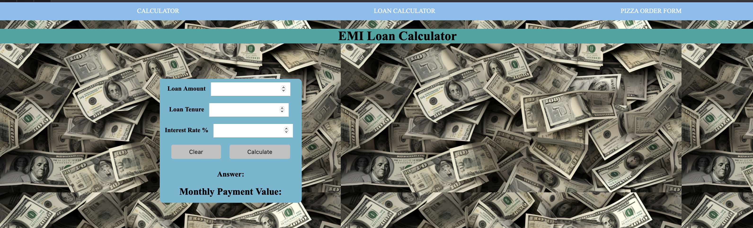

# PIZZA ORDER FORM:

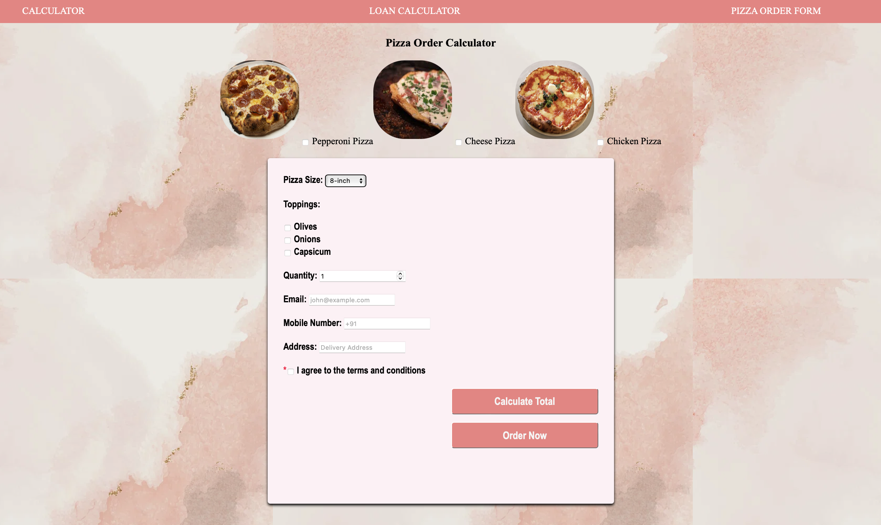

**RESULT:**

JavaScript – DOM elements and Events are successfully created with Html and CSS .